Linear Induction Motor

A type of induction motor that is used to attain linear motion instead of rotating motion by changing the input of electrical energy to linear motion is known as a linear induction motor. As with rotary motors, linear motors frequently run on a three-phase power supply and can support very high speeds.They are therefore often used where contactless force is required, where low maintenance is desirable, or where the duty cycle is low.

Linear Induction Motor – Construction:

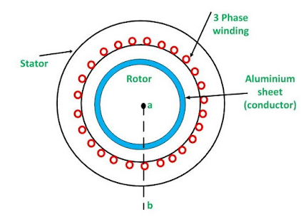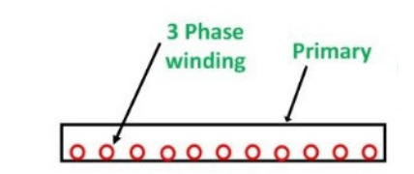

Linear Induction Motor

In this type of motor, the stator and rotor are called ***primary*** and ***secondary***. The secondary of the linear induction motor consists of a flat Aluminium conductor with a ferromagnetic core. So, Primary of Linear Induction Motor is flat and three phase winding is wound on it. Now if we make the Rotor of Induction Motor flat then it will be nothing but a sheet of flat Aluminium.

Working

Once power is given to the motor, these two will interact with each another but the primary must be fixed while the secondary moves. If a three-phase supply is given to the primary of this motor then a magnetic flux can be generated which will move across the primary length. So due to this magnetic flux moving, a current will be produced within the conductor. The current induced within the secondary of this motor will interact with the traveling flux & generates a linear force or linear motion. The 3- phase supply is provided to the stator winding, then a magnetic field can be formed. So, this field moves at a liner synchronous speed which can be given as

**Vs = 2τf m/ sec**

‘τ’ is the Pole pitch in the meter. ‘f’ is Frequency in Hz.

Here the synchronous speed is not directed through the number of poles and any preferred linear speed can be attained by changing pole pitch When flux moves linearly then it induces currents within the rotor plate. So, the induced currents interacting through the field generate thrust on the rotor plate & pull the rotor plate in a similar direction. Similar to a cylindrical induction motor, this induction motor also works at below synchronous speed because it can’t run at synchronous speed. When this motor is an induction or asynchronous motor, therefore the secondary coil speed is not high at the synchronous speed. The main difference between these two speeds is called slip. So the linear induction motor’s slip can be given by

Linear induction motor slip**(s) = (vs – v)/vs**

Linear Induction Motor – Characteristics

* Whenever this motor begins from an inactive condition & speeds up to a synchronous speed, then thrust force attains a maximum at a translation speed & after that, it falls.
* This is due to the amount of difference within the magnetic flux in the aluminum sheet being decreased when the difference in the magnetic field produced through the coil attains a synchronous speed.

Linear Induction Motor vs Induction Motor

* Linear induction motors have a magnetic core that is fixed to the stator, which helps to maintain alignment with the rotor.
* This means that there is no need for an external power source or control system to keep the rotor properly aligned with the stator.
* In addition, because there is no need for brushes or slip rings, linear induction motors are much simpler than standard induction motors.

Advantages: These motors are not expensive. Simple construction. Maintenance cost is less because of the deficiency of rotating parts. There is no limitation for maximum speed because of centrifugal forces.These are used in long-length applications because they don’t have secondary parts

Disadvantages: This motor has a larger air gap which is typically 25 mm, so it results in less power factor. The larger air-gap & non-magnetic reaction rail requires more magnetizing current which results in a low-power factor & poor efficiency. The efficiency of this motor is low & they generate more heat.

Applications: These help in handle materials in cranes. Transportation wherever the primary is arranged on the vehicle & the secondary is laid through the track.Used like an actuator for movement of the door.These motors are utilized within accelerators for rigs to test the performance of the vehicles in impact conditions.These are used in conveyors, electromagnetic pumps & trolley cars.